**Project Design Phase**

**Solution Architecture**

|  |  |
| --- | --- |
| Date | 23 June 2025 |
| Team ID | LTVIP2025TMID55293 |
| Project Name | HOUSE RENT APP USING MERN |
| Maximum Marks | 4 Marks |

**Solution Architecture:**

solution architecture for HouseHunt plays a crucial role in bridging the gap between rental market challenges and effective technological solutions. It ensures that our platform not only meets user needs but also scales efficiently with future growth. Its goals are to:

**Identify the most suitable technological stack (MERN)** to solve current real estate rental challenges, such as property discovery, booking, and verification.

**Define the structure, behavior, and user interaction flow** of the HouseHunt web application in a clear and understandable way for all stakeholders, including developers, owners, tenants, and admins.**Outline essential features, development**

**milestones, and key solution requirements** like user roles, secure communication, property listing workflows, and booking status management.

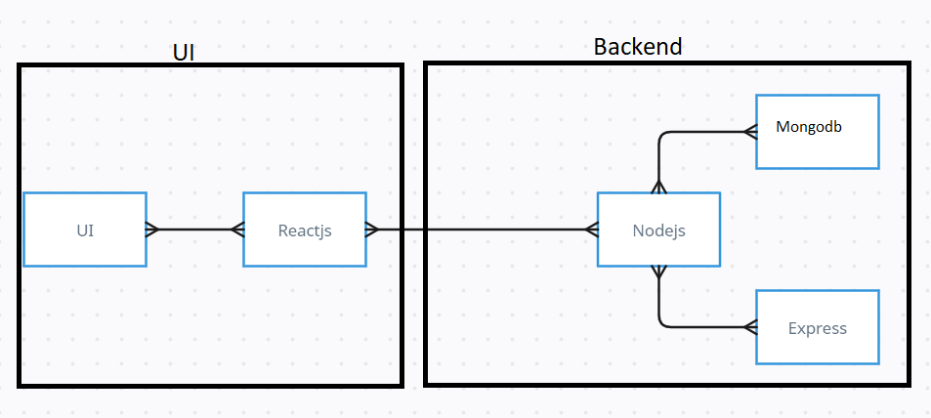**Establish specifications** for how HouseHunt should be built, maintained, and delivered — ensuring performance, security, and usability standards are consistentlym

**Solution Architecture Diagram:**